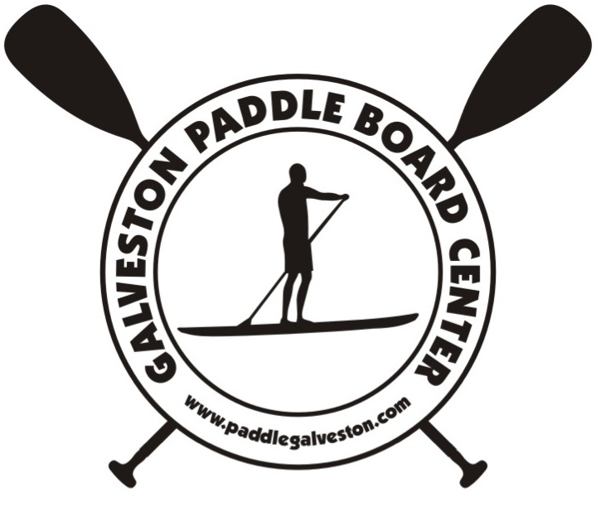
GALVESTON PADDLEBOARD CENTER RENTAL AGREEMENT

PERSONAL INFORMATION:

NAME: ____________________________________________ E-MAIL: ________________________________________________

PHONE NUMBER: ____________________________________ EMERGENCY CONTACT: ___________________________________

CHECK OUT TIME/DATE: _______________________________ RETURN TIME/DATE: _____________________________________

RENTAL PACKAGE:

Stand Up Paddle (SUP): $25 per hour

Stand Up Paddle (SUP): $45 per day

Board Insurance: $5/day Yes No

CREDIT CARD INFORMATION:
CREDIT CARD INFORMATION:
NAME ON CARD: ______________________________________________________________________
CARD NUMBER: _______________________________________________________________________
EXPIRATION DATE: ____________________________________________________________________
CVS CODE: ___________________________________________________________________________

TERMS AND CONDITIONS:

Payments must be made in full at the signing of this agreement.
Renter’s credit card details will be retained on file as security deposit.
There are no refunds on early returns.
All renters must be competent swimmers, and by signing the attached Waiver and Assumption of Risk Release Agreement, the renter is declaring that he/she is a competent swimmer.

WAIVER AND ASSUMPTION OF RISK RELEASE AGREEMENT

The undersigned, on behalf of myself and my family, heirs, assigns, personal representatives and estate, voluntarily makes and grants this Waiver and Assumption of Risk Agreement in favor of Galveston Paddleboard Center and Southern Spears Surf its agents, owners, members, managers, employees, and all other persons or entities acting in any capacity on its behalf (hereinafter "Galveston Paddleboard Center").

I hereby waive, discharge, release and agree to indemnify Galveston Paddleboard Center from and against any and all claims of damage, negligence or liability arising out of my use or misuse of equipment provided, including surfboards, surfboard gear, stand-up paddle boards, and any other product offered by Galveston Paddleboard Center. Further, I waive any and all claims that I have or may in the future have against Galveston Paddleboard Center and release Galveston Paddleboard Center from any and all liability. I fully understand, recognize, and acknowledge that surfing and paddleboarding are hazardous activities with inherent risks and dangers that could result in, among other things, injury to myself or others, damage to my equipment or the equipment of others, or even death, and which I nevertheless accept. I voluntarily release, forever discharge, and agree to indemnify Galveston Paddleboard Center from any and all claims, demands, losses, costs, attorneys’ fees, damages and causes of action that are in any way connected with my participation in surfing or paddleboarding activities and/or use of Galveston Paddleboard Center’ equipment, including any claims that allege negligent acts or omissions by Galveston Paddleboard Center.

As a condition of the use of the Galveston Paddleboard Center equipment, I will assume all responsibility for any injury or damage of any nature and extent caused by or resulting from my use or misuse of the equipment. I agree to use my best judgment in undertaking this activity (surfing or paddleboarding), and I expressly agree to assume all of the known and unknown risks associated therewith. I hereby certify that I am a competent adult assuming the risks of my own free will, being under no compulsion or duress.
I will further assume all responsibility for returning the surfboards/paddleboards/gear in good condition at the end of the rental period and to pay all repair and/or replacement costs for any damage or theft that may occur to the equipment during the rental period. Should I damage a surfboard, I agree to pay a damage fee of $20/ inch (maximum liability for surfboard damage, excluding theft, is $200). Should Galveston Paddleboard Center or anyone acting on its behalf be required to incur attorney's fees and costs to enforce this agreement, I agree to indemnify and hold them harmless for all such fees and costs. I certify that I have adequate insurance to cover any injury or damage I may cause or suffer while using Galveston Paddleboard Center’ equipment, or I agree to bear the costs of such injury or damage myself.

Should I file a lawsuit against Galveston Paddleboard Center, I agree to do so solely in a court in Galveston County, Texas, and I further agree that the substantive law of Texas shall apply in that action without regard to conflict of law rules. I agree that if any part of this Agreement is found to be invalid or unenforceable, the remaining portions shall remain in full force and effect.

By signing this Agreement, I acknowledge that if anyone is hurt or property is damaged during my participation in this activity or from the use of Galveston Paddleboard Center’ equipment, I have waived my right to maintain a lawsuit against Galveston Paddleboard Center. I have had an opportunity to read this entire Agreement, I understand it, and I agree to be bound by its terms.

Signature: ______________________________________________ Date: __________________

Print Name:_____________________________________________

PARENT’S OR GUARDIAN’S ADDITIONAL INDEMNIFICATION (for participants under the age of 18)

In consideration of________________________________ (print minor's name) ("Minor") being permitted by Galveston Paddleboard Center to use its equipment, I further agree to indemnify and hold harmless Galveston Paddleboard Center from any and all Claims that are brought by, or on behalf of Minor, and which are in any way connected with such use or misuse by Minor.

Parent or Guardian Signature: _____________________________________________

Print Name: ___________________________________________ Date: __________

